# Роль Селина Павла.
https://gitlab.tcsbank.ru/das/clamav.git
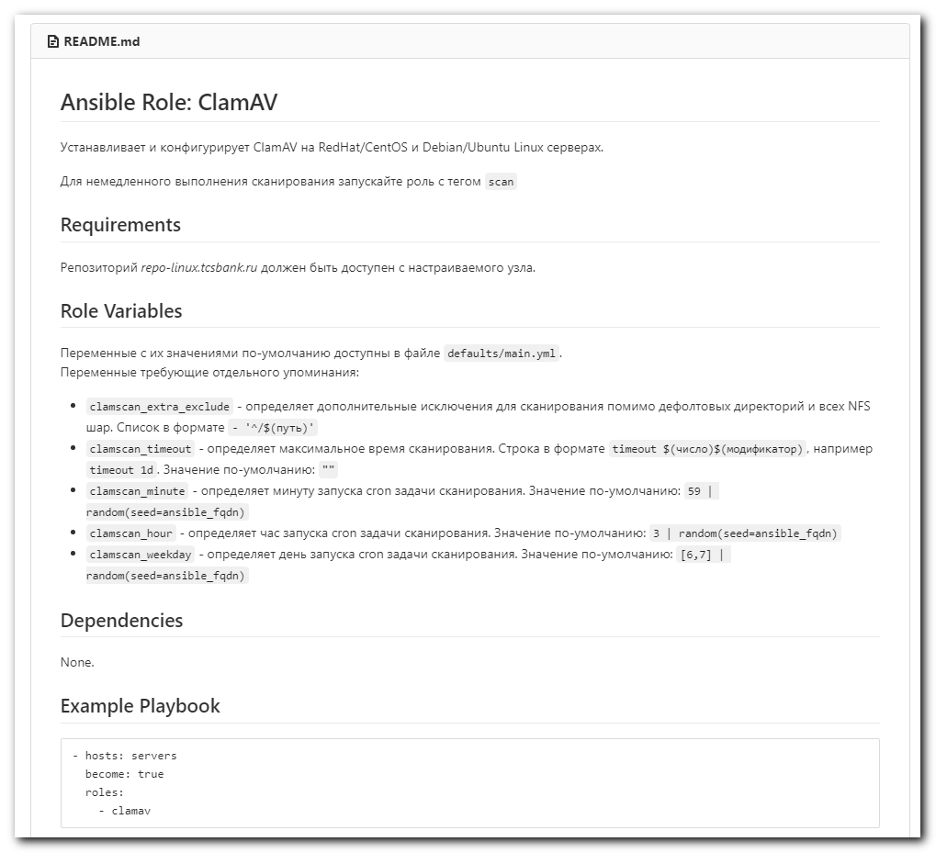

# At the first time attempts was unsuccessful.
# It's under WSL Ubuntu 20.04
#
[support@nb2339]# git clone -c http.sslVerify=false https://gitlab.tcsbank.ru/das/clamav.git
Cloning into 'clamav'...
Username for 'https://gitlab.tcsbank.ru': s.belogrud
Password for 'https://s.belogrud@gitlab.tcsbank.ru':
remote: HTTP Basic: Access denied
fatal: Authentication failed for 'https://gitlab.tcsbank.ru/das/clamav.git/'
[support@nb2339]# git clone ssh://s.belogrud@gitlab.tcsbank.ru:7999/das/clamav.git
Cloning into 'clamav'...
s.belogrud@gitlab.tcsbank.ru's password:
Permission denied, please try again.
s.belogrud@gitlab.tcsbank.ru's password:

[support@nb2339]#

# Here I imported ssh key. This is only this way I found, how to connect to gitlab with ssh key. I remember there was another one - write a section into /etc/ssh/ssh.cfg and in this section write DNS name of gitlab server and write which ssh key use to connect to it.
#
[support@nb2339]# eval $(ssh-agent -s)
Agent pid 185
[support@nb2339]#
[support@nb2339]# ssh-add ~/.ssh/id_rsa_s.belogrud
Identity added: /home/support/.ssh/id_rsa_s.belogrud (/home/support/.ssh/id_rsa_s.belogrud)
[support@nb2339]#

[support@nb2339]# git clone ssh://git@gitlab.tcsbank.ru:7999/das/clamav.git
Cloning into 'clamav'...
remote: Enumerating objects: 269, done.
remote: Total 269 (delta 0), reused 0 (delta 0), pack-reused 269
Receiving objects: 100% (269/269), 31.08 KiB | 1.64 MiB/s, done.
Resolving deltas: 100% (94/94), done.
[support@nb2339]# ll
total 0
drwxrwxrwx 1 support support 512 Aug 16 17:58 ./
drwxrwxrwx 1 support support 512 Aug 16 17:32 ../
drwxrwxrwx 1 support support 512 Aug 16 17:58 clamav/
[support@nb2339]#

[support@nb2339]# mv clamav clamav.orig
[support@nb2339]#

# This I made under MobaXterm.
[s.belogrud@nb2339]# mkdir clamav

[s.belogrud@nb2339]# mv clamav.orig/* clamav/
[s.belogrud@nb2339]# mv clamav.orig/.* clamav/
mv: can't rename 'clamav.orig/.': Invalid argument
mv: can't rename 'clamav.orig/..': Invalid argument
[s.belogrud@nb2339]#
[s.belogrud@nb2339]# rmdir clamav.orig/

[s.belogrud@nb2339]# pwd
/drives/c/data/work/ansible/gitlab.tcsbank.ru/roles/das/clamav
[s.belogrud@nb2339]# ll
total 2
drwxr-xr-x 1 s.belogr UsersGrp 0 Aug 16 18:01 clamav
[s.belogrud@nb2339]# mv clamav/* ./
[s.belogrud@nb2339]# mv clamav/.git* ./
[s.belogrud@nb2339]# ls -Alh clamav/
total 1
-rwxr-xr-x 1 s.belogr UsersGrp 52 Aug 16 17:58 .yamllint
[s.belogrud@nb2339]# mv clamav/.yamllint ./
[s.belogrud@nb2339]# rmdir clamav
[s.belogrud@nb2339]#

#
# I edited .git/config same was as I did it here 20210708 vm-gitlab01 repository clamav_signatures
#
[s.belogrud@nb2339]# vim .git/config

[s.belogrud@nb2339]# cat .git/config
[core]
repositoryformatversion = 0
filemode = false
bare = false
logallrefupdates = true
ignorecase = true
sshCommand = ssh -o UserKnownHostsFile=/dev/null -o StrictHostKeyChecking=no -o LogLevel=ERROR
[remote "origin"]
url = ssh://git@gitlab.tcsbank.ru:7999/das/clamav.git
fetch = +refs/heads/*:refs/remotes/origin/*
[branch "master"]
remote = origin
merge = refs/heads/master
[ssh]
identity = /home/mobaxterm/.ssh/id_rsa_s.belogrud

[s.belogrud@nb2339]#

[s.belogrud@nb2339]# git pull
stty: standard input: Inappropriate ioctl for device
Warning: Permanently added '[gitlab.tcsbank.ru]:7999' (RSA) to the list of known hosts.
Уже обновлено.
[s.belogrud@nb2339]#

#
# I created empty directories: output, retry, collection.
# And I copyed files ansible.cfg. And created file list_of_hosts.
# And by the way I copied file 20210816-1812.clamav.yml, renamed it and edited it.
#
[s.belogrud@nb2339]# ls -Alh /drives/c/data/work/ansible/gitlab.tcsbank.ru/
total 3
-rwxr-xr-x 1 s.belogr UsersGrp 541 Aug 16 18:16 20210816-1812.clamav.yml
-rwxr-xr-x 1 s.belogr UsersGrp 687 Jun 11 15:24 ansible.cfg
drwxr-xr-x 1 s.belogr UsersGrp 0 Aug 16 18:18 collection
-rwxr-xr-x 1 s.belogr UsersGrp 129 Aug 16 18:16 list_of_hosts
drwxr-xr-x 1 s.belogr UsersGrp 0 Aug 16 18:17 output
drwxr-xr-x 1 s.belogr UsersGrp 0 Aug 16 18:17 retry
drwxr-xr-x 1 s.belogr UsersGrp 0 Aug 16 17:32 roles
[s.belogrud@nb2339]#

[support@nb2339]# export ANSIBLE_CONFIG=ansible.cfg ; logfile="$(date +%Y%m%d-%H%M).playbook.log.txt" ; ansible-playbook 20210816-1812.clamav.yml -i list_of_hosts --become --extra-vars "ansible_user=unix-ansible ansible_password=$(pass common/linux-unix-ansible) ansible_sudo_pass=$(pass common/linux-unix-ansible) ansible_ssh_common_args='-oStrictHostKeyChecking=no -oPubkeyAuthentication=no -oUserKnownHostsFile=/dev/null'" --tags package --check | tee -a ./output/${logfile}

[support@nb2339]# export ANSIBLE_CONFIG=ansible.cfg ; logfile="$(date +%Y%m%d-%H%M).playbook.log.txt" ; ansible-playbook 20210816-1812.clamav.yml -i list_of_hosts --become --extra-vars "ansible_user=s_s.belogrud ansible_password=$(pass common/linux-freeipa) ansible_sudo_pass=$(pass common/linux-freeipa) ansible_ssh_common_args='-oStrictHostKeyChecking=no -oPubkeyAuthentication=no -oUserKnownHostsFile=/dev/null'" --tags package --check | tee -a ./output/${logfile}

[support@nb2339]# export ANSIBLE_CONFIG=ansible.cfg ; logfile="$(date +%Y%m%d-%H%M).playbook.log.txt" ; ansible clamav -i list_of_hosts -m shell -a "hostname ; yum list installed clamav" --become --extra-vars "ansible_user=s_s.belogrud ansible_password=$(pass common/linux-freeipa) ansible_sudo_pass=$(pass common/linux-freeipa) ansible_ssh_common_args='-oStrictHostKeyChecking=no -oPubkeyAuthentication=no -oUserKnownHostsFile=/dev/null'" | tee -a ./output/${logfile}
m1-db-tst09.tcsbank.ru | CHANGED | rc=0 >>
m1-db-tst09
Loaded plugins: langpacks, product-id, search-disabled-repos, subscription-
: manager
This system is not registered with an entitlement server. You can use subscription-manager to register.
Installed Packages
clamav.x86_64 0.103.3-1.el7 @tcs-epel
m1-db-tst28.tcsbank.ru | CHANGED | rc=0 >>
m1-db-tst28.tcsbank.ru
Loaded plugins: langpacks, product-id, search-disabled-repos, subscription-
: manager
This system is not registered with an entitlement server. You can use subscription-manager to register.
Installed Packages
clamav.x86_64 0.103.3-1.el7 @repo-linux.tcsbank.ru_epel_7Server_x86_64_
m1-db23-stb.tcsbank.ru | CHANGED | rc=0 >>
m1-db23-stb
Loaded plugins: langpacks, product-id, search-disabled-repos, subscription-
: manager
This system is not registered with an entitlement server. You can use subscription-manager to register.
Installed Packages
clamav.x86_64 0.103.3-1.el7 @repo-linux.tcsbank.ru_epel_7Server_x86_64_
m1-db-tst30.tcsbank.ru | CHANGED | rc=0 >>
m1-db-tst30.tcsbank.ru
Loaded plugins: langpacks, product-id, search-disabled-repos, subscription-
: manager
This system is not registered with an entitlement server. You can use subscription-manager to register.
Installed Packages
clamav.x86_64 0.103.3-1.el7 @repo-linux.tcsbank.ru_epel_7Server_x86_64_
[support@nb2339]#

